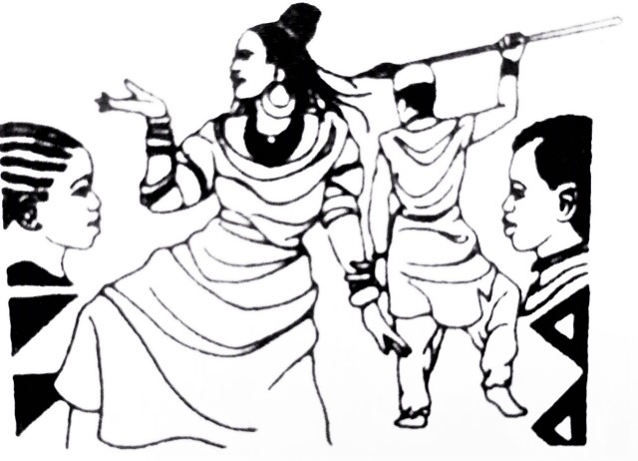 Request for Service with Manga African Dance
Billing Company:
Billing name:
Company address:

Title:
Phone #:
Email:
Date: Service (please check that apply): Performance__ Workshop__ Both___
In person _____ Virtual_____ Pre-recorded____

Description
Event:
Date: Duration:
Start time: Program Grade #Children #Adults
Presentation #1:
Presentation #2:
Presentation #3:
Address of site:

Person to contact on site: Phone #:
Instructions for Performers:

Manga’s comment:
Reservations have to be booked 25 business days in advance.
All paperwork (service request and billing invoice) must be received via email by the Program Manager at mangadance@yahoo.com.
Please note that if all paperwork is not received within the designated period, the Client could lose the appointed time.
To make changes to these services or to request cancellation of a service, contact Program Manager via email.
Request cancellation has to be received 20 business days in advance

Thank you!
Manga African Dance

